Practical EU Animal Transport Guides for cattle, sheep, horses, pigs and poultry now available

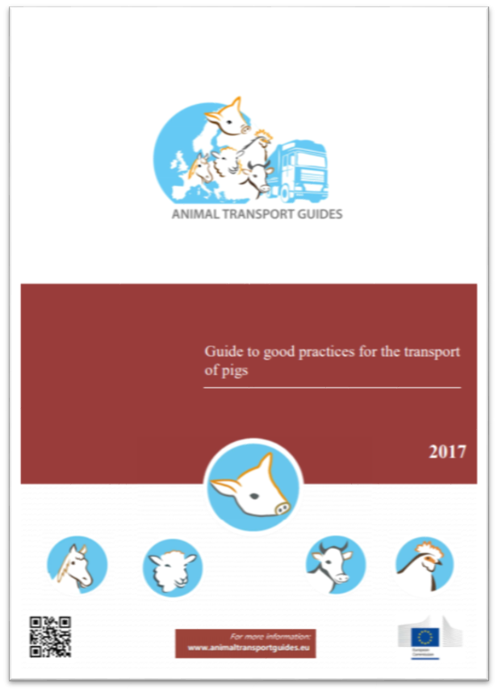
Practical EU Guides to Good Practice for cattle, sheep, horses, pigs and poultry are now available. These Guides provide practical advice to professionals to ensure that the animals they transport remain in good welfare.

Such Guides have been written in the framework of a dedicated European project funded by the European Commission, by a large consortium of research institutes from 10 countries and stakeholder organisations, including input from leading EU agri-food, veterinary, road transport and animal welfare stakeholder groups.

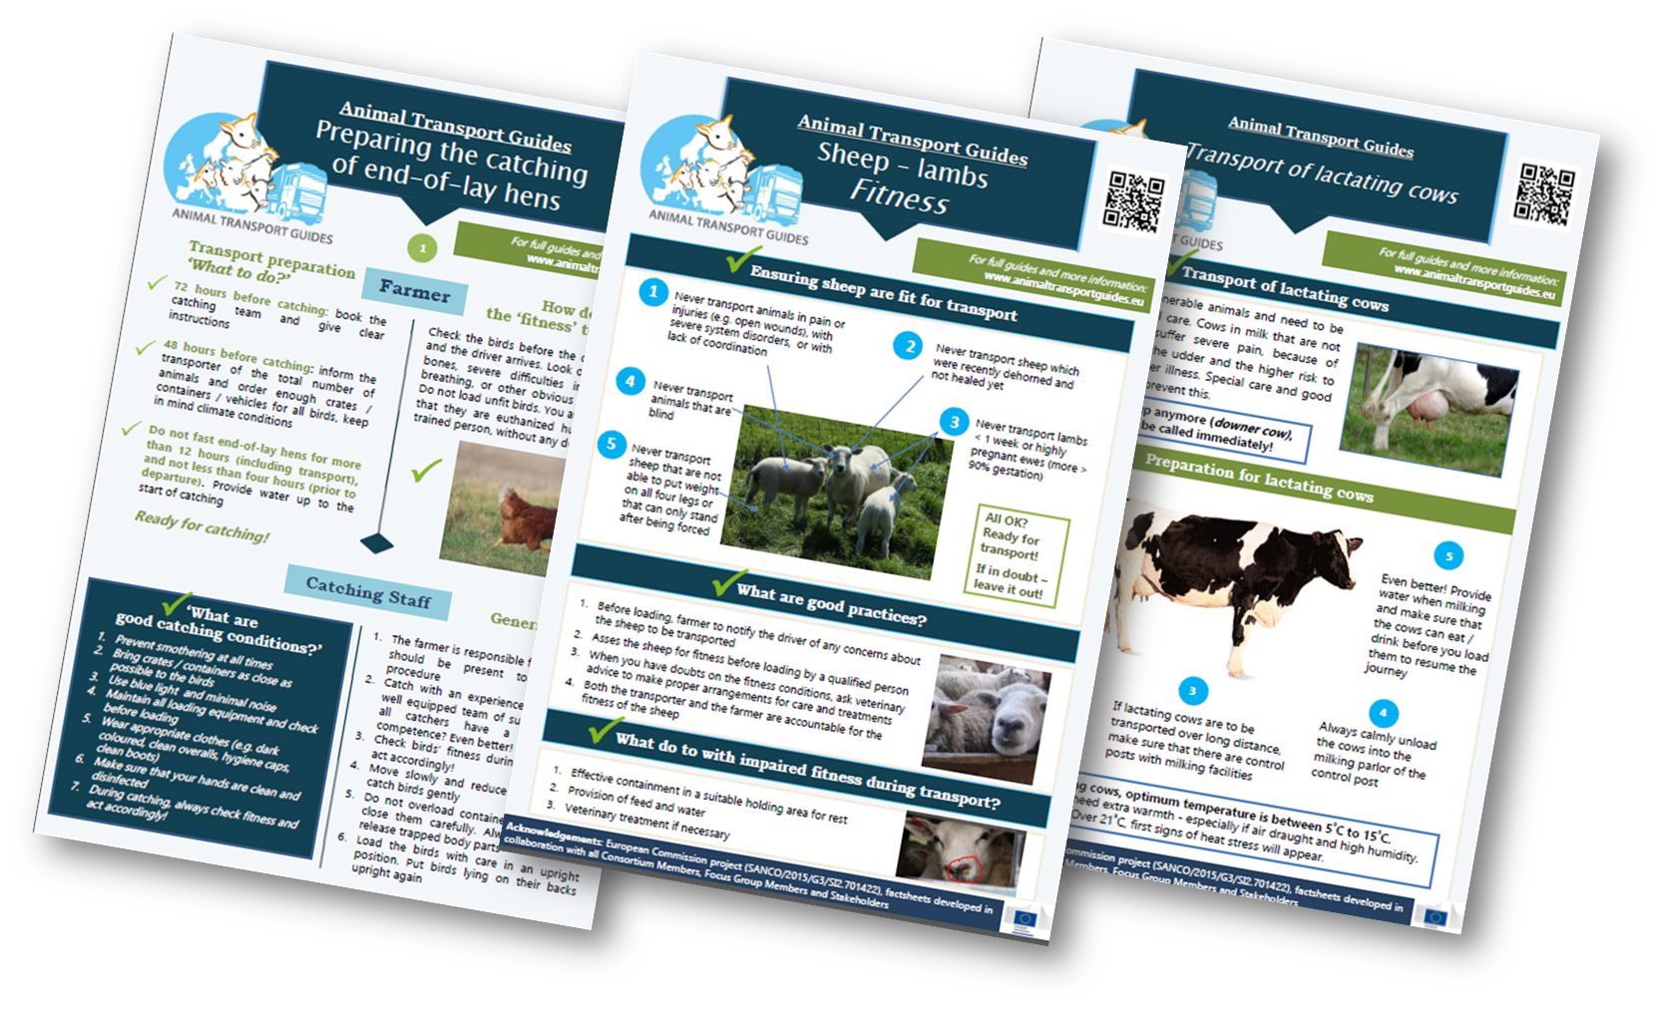
The Guides are supplemented by 17 practical easy-to-understand Factsheets (available in 8 languages) which help and give advice on the most critical aspects around transport such as loading and unloading, feeding and watering and transportation in extremely hot or cold temperatures.

Respecting the welfare of animals during transport is in the interest of all operators involved. Farmers' sending animals see their work respected, transporters save time and money, operators receiving animals get them in good shape, allowing better returns. The whole sector can be proud of respecting societal concerns. On the other hand, neglecting animals may lead to serious economic losses, penalties and administrative sanctions.

These Guides and Factsheets represent an invaluable source of information for all involved in the transport of livestock.

More information on the creation process and development of the guides can be found at the Animal Transport Guides website (www.animaltransportguides.eu). Updates in the project can be followed by subscribing to the Animal Transport Guides newsletter (link to subscribe).

